Experimental setup presentation

The I-OB building is located on the INCAS experimental platform at INES in Le Bourget du Lac, France (latitude: 45°38′38.5 N; longitude: 5°52′27.4″ E; elevation: 235m) (Figure 1). The time zone is CEST (UTC+2 during the summer period). The climate is classified as Cfb (temperate, no dry season, warm summer) by Köppen and Geiger and H1c by French environmental regulations. The experimental campaign ran from May 26th to September 3rd 2023.

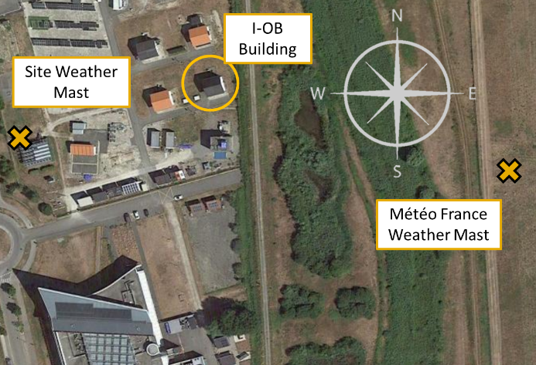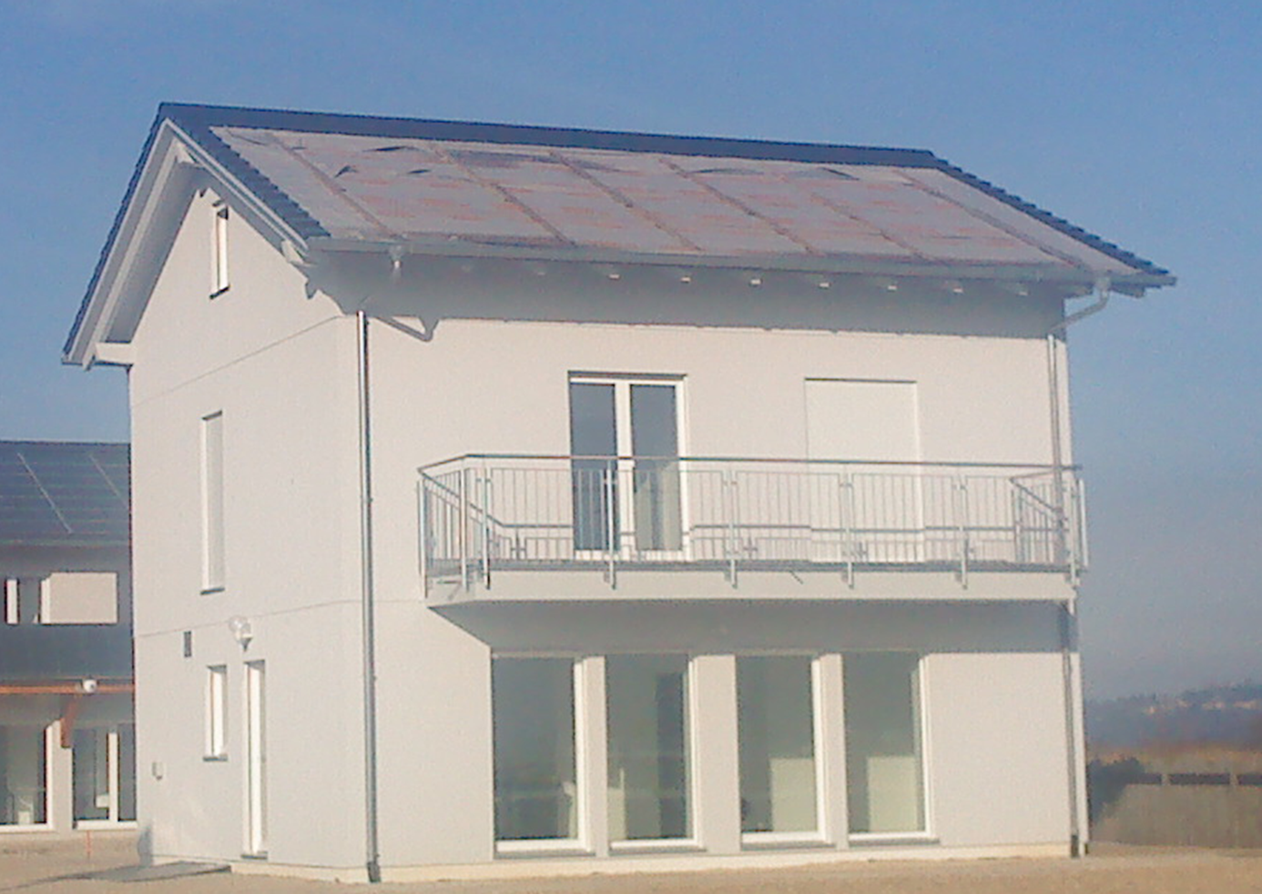
Figure 1: I-OB building overall view with surrounding environment and weather mast position

Physical | Nomenclature | Unit | Model | Accuracy | Height (m) | 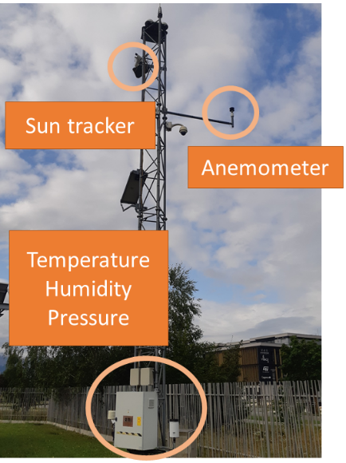
Temperature | T_a | °C | CAMPBELL CS215 | ±0,4°C (5°C to 40°C) | 1,5
Humidity | RH_a | % | CAMPBELL CS215 | ±2% (10% to 90%) at 25°C | 1,5
Patm | P_a | Pa | SETRA 278 | NA | 1,5
Global Horizontal | S_GH | W/m2 | NA | NA | 11
Beam normal | S_BN | W/m2 | Pyrheliometer KIPP&ZONEN CHP1 | NA | 11
Sun Altitude | S_Al | deg | EKO STR21 | NA | 11
Sun Azimuth | S_Az | deg | EKO STR21 | NA | 11
Wind speed | WS | m/s | Gill Instruments WindSonic | ±2% reading | 10
Wind Direction | WD | deg | Gill Instruments WindSonic | ±2° | 10
Exterior CO2 | CO2_Ext | ppm | Kimo COT212 | ±3 % reading ±50 ppm | NA
Table 1: INES site weather mast sensor specifications and nomenclature of associated variables

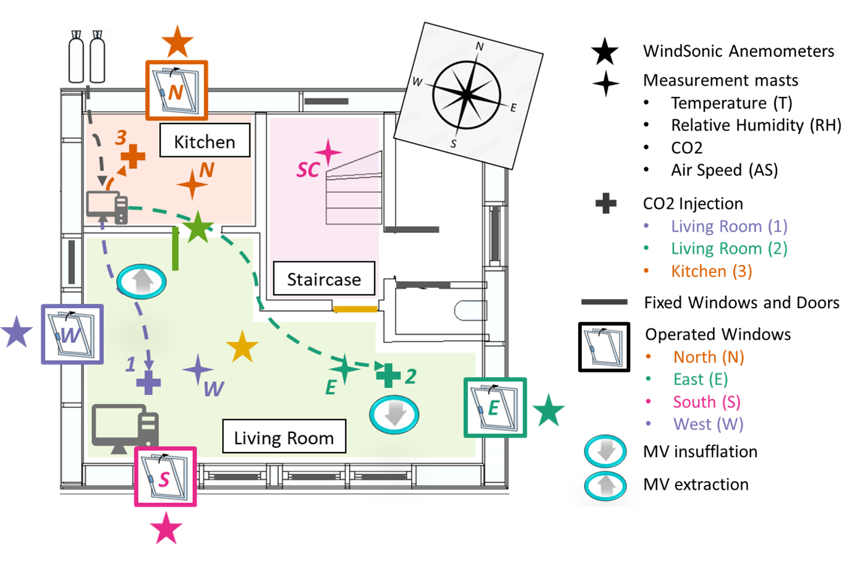
Figure 2: Sketch of the experimental setup and sensors position

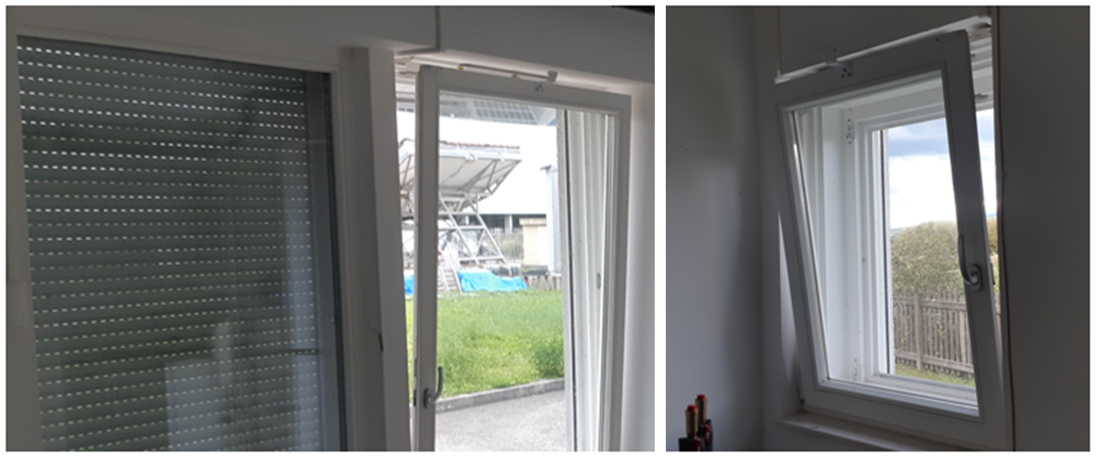
Figure 3: Left: closed window with roller shutter next to tilt-opened window at south wall. Right: tilt-opened window at east wall.

Physical | Nomenclature | Unit | Material | Range | Accuracy
CO2 Injection | Injec_x | l/h | Serv’Instrumentation massflow meters and controllers 5850S | 0-70l/h | ± 0.7 % reading ± 0.14 l/h
Window openings | Win_x | True/False | MINI MEGA 230Vca; MM20 150 | 0-150 mm
MV | Q_MV_in | m3/h | Atlantic dualixMax 412137 90-300m3/h | Efficiency up to 92%
Table 2: Controllers specifications and nomenclature of associated variables

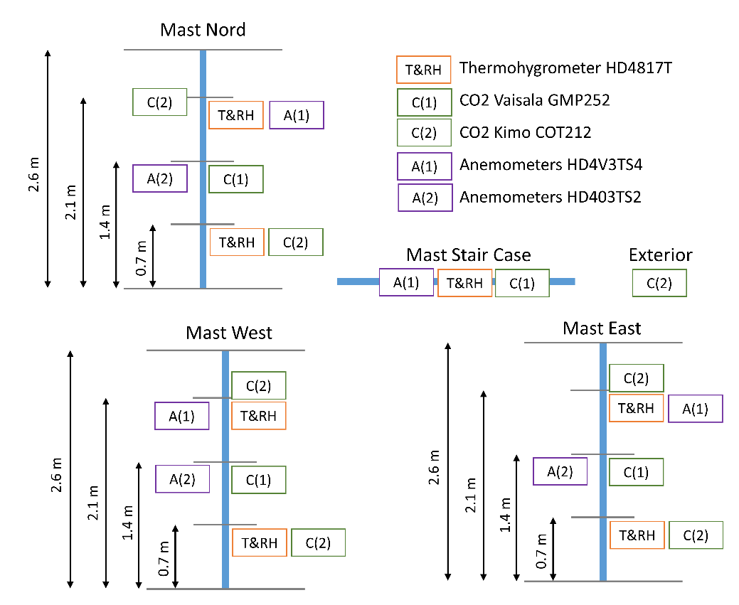
Figure 4: Detail of sensors reference and position on the monitoring masts

Physical | Nomenclature | Unit | Model | Operating temperature range | Accuracy
Temperature | T_x | °C | Thermohygrometer DeltaOhm HD4817T | -20°C / +80°C | ± 0.3°C
Humidity | RH_x | % | Thermohygrometer DeltaOhm HD4817T | -20°C / +80°C | ±2 %
WindSonic Air Speed | AS_x | m/s | Gill Instruments WindSonic | -35°C / +70°C | ± 2% reading
WindSonic Air Direction | AD_x | deg | Gill Instruments WindSonic | -35°C / +70°C | ± 2°
Air Speed | AS_x | m/s | Hot Wire Anemometer Omnidirectional DeltaOhm HD4V3TS4 | 0°C / +60°C | ±3 % reading ±0.2 m/s
Air Speed | AS_x | m/s | Hot Wire Anemometer Omnidirectional DeltaOhm HD403TS2 | 0°C / +60°C | ±3 % reading ±0.2 m/s
CO2 | CO2_x | ppm | Vaisala GMP252 | -40°C / +60°C | ±2 % reading ±40 ppm
CO2 | CO2_x | ppm | Kimo COT212 | -10°C / +50°C | ±3 % reading + ±50 ppm
Table 3: Building sensor specification and nomenclature of associated variables

Variables in the dataset

Nomenclatures:
Time scale | Weather data | Building data | Measured T RH | Measured AS AD | Measured CO2
Date_UTC  [yyyy-mm-dd hh:mm:ss] | T_a [°C] | N_K [/] | T_SC [°C] | AS_SC [m/s] | CO2_SC [ppm]
Date_UTC  [yyyy-mm-dd hh:mm:ss] | RH_a [%] | N_LR [/] | T_E_210 [°C] | AS_E_210 [m/s] | CO2_E_210 [ppm]
 | P_a [Pa] | Met_Mean_P | T_E_70 [°C] | AS_E_140 [m/s] | CO2_E_140 [ppm]
 | S_GH [W/m2] | Injec_1 [l/h] | T_W_210 [°C] | AS_W_210 [m/s] | CO2_E_70 [ppm]
 | S_BN [W/m2] | Injec_2 [l/h] | T_W_70 [°C] | AS_W_140 [m/s] | CO2_W_210 [ppm]
 | S_DH [W/m2] | Injec_3 [l/h] | T_N_210 [°C] | AS_N_210 [m/s] | CO2_W_140 [ppm]
 | S_Al [deg] | Win_S [/] | T_N_70 [°C] | AS_N_140 [m/s] | CO2_W_70 [ppm]
 | S_Az [deg] | Win_E [/] | RH_SC [%] | AS_IndoorLR_150 [m/s] | CO2_N_210 [ppm]
 | WS [m/s] | Win_W [/] | RH_E_210 | AD_IndoorLR_150 [deg] | CO2_N_140 [ppm]
 | WD [deg] | Win_N [/] | RH_E_70 [%] | AS_DoorK_150 [m/s] | CO2_N_70 [ppm]
 |  | Door_K [/] | RH_W_210 [%] | AD_DoorK_150  [deg] | CO2_Ext [ppm]
 |  | Door_LR [/] | RH_W_70 [%] | AS_Ext_150_N [m/s]
 |  | Win_Conf [/] | RH_N_210 [%] | AD_Ext_150_N [deg]
 |  | Q_MV_in [m3/s] | RH_N_70 [%] | AS_Ext_150_E [m/s]
 |  | V_K [m3] |  | AD_Ext_150_E [deg]
 |  | V_LR [m3] |  | AS_Ext_150_S [m/s]
 |  |  |  | AD_Ext_150_S [deg]
 |  |  |  | AS_Ext_150_W [m/s]
 |  |  |  | AD_Ext_150_W [deg]

Table 4: Nomenclature and unit for all variables in the data frame

Handling missing data:
- External CO2 measurement were missing the 2023/06/22 and were replaced by the base value 450ppm.
- Site wind speed and wind direction measurement were missing for the period [2023/06/29 - 2023/07/17] and [2023/07/24 - 2023/08/02] and were replaced by measurement from the nearby Météo-France mast from Chambery-Aix Airport (latitude: 45°38'28.7" N; longitude: 5°52'40.8" E) (Figure 1). The supplied 6-minute time step data are linearly interpolated to a 1-minute time step.
- Missing measurement can occasionally appear such as in [2023/07/12 13:22 UTC - 2023/07/12 14:53 UTC].
- All weather data are missing for the period [2023/06/10-2023/06/12].
Finally, it is the author’s choice not to apply any further corrections to the shared dataset, such as noise filtering, outliers removal, time averaging or spatial averaging. Nevertheless, depending on research needs, data may be further processed for better interpretability.

Dataset statistics
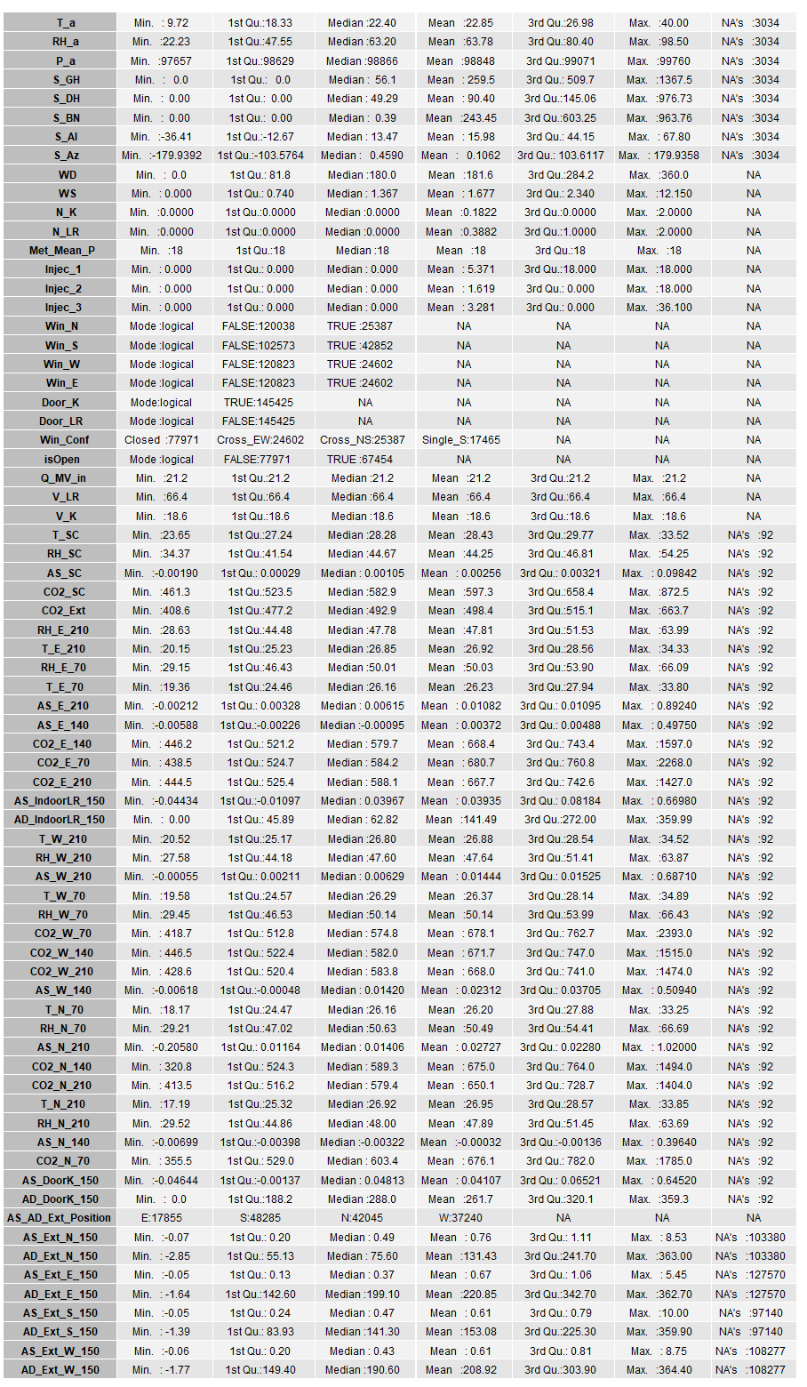
Table 5: All variables statistics

Boxplot for CO2 concentration and temperatures distributions among all sensors

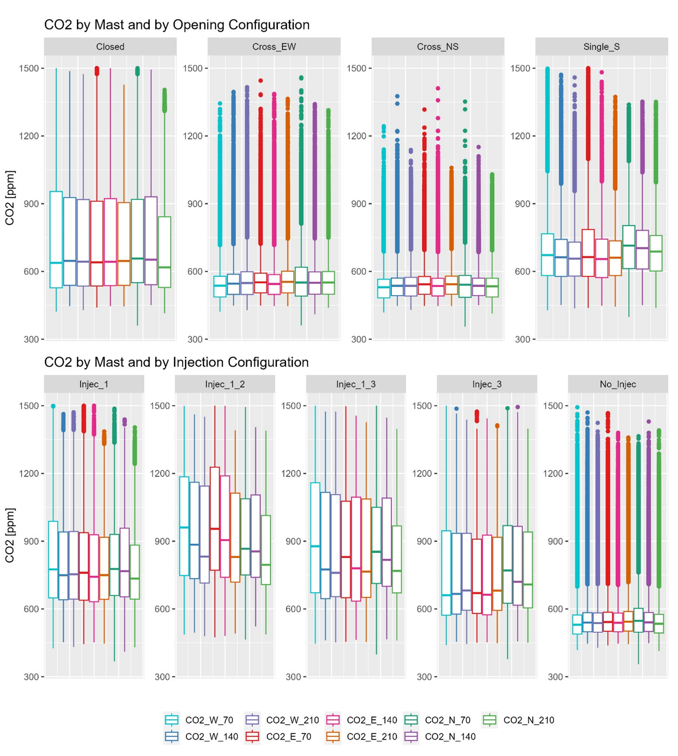
Figure 5: CO2 distribution at different position and height. Top: separated by opening configurations. Bottom: separated by injection configuration

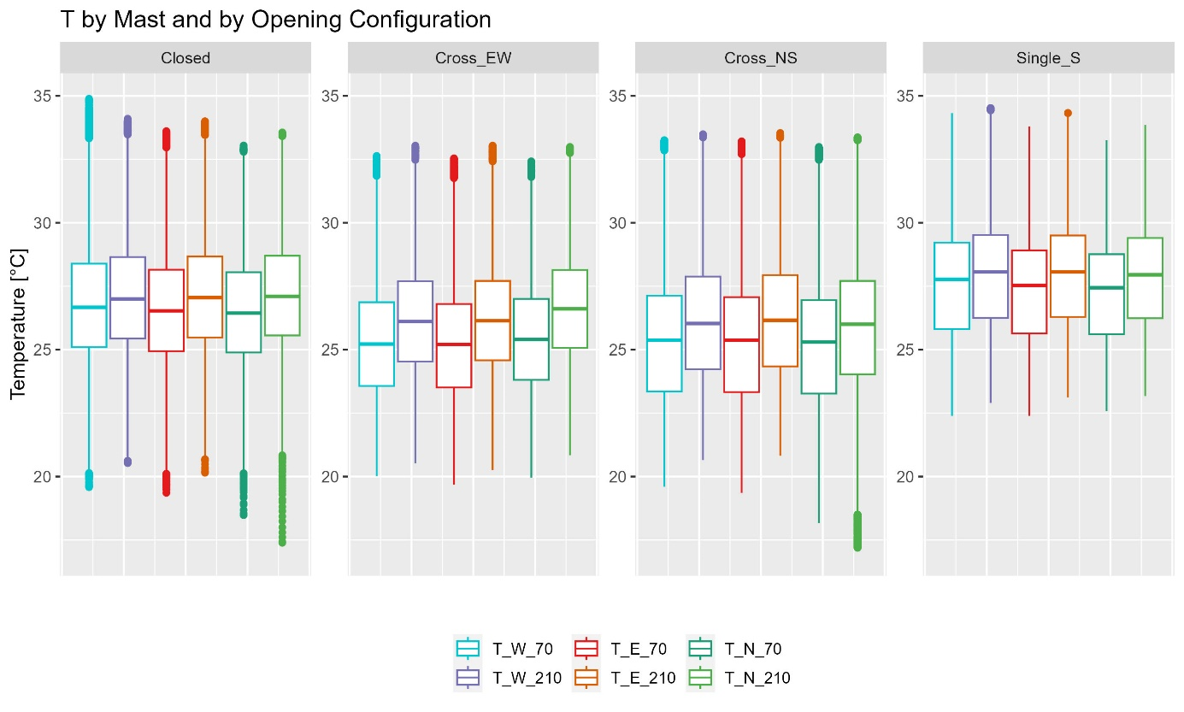
Figure 6: Temperatures distribution at different position and height. Separated by opening configurations.

Detailed data visualizations for the whole campaign
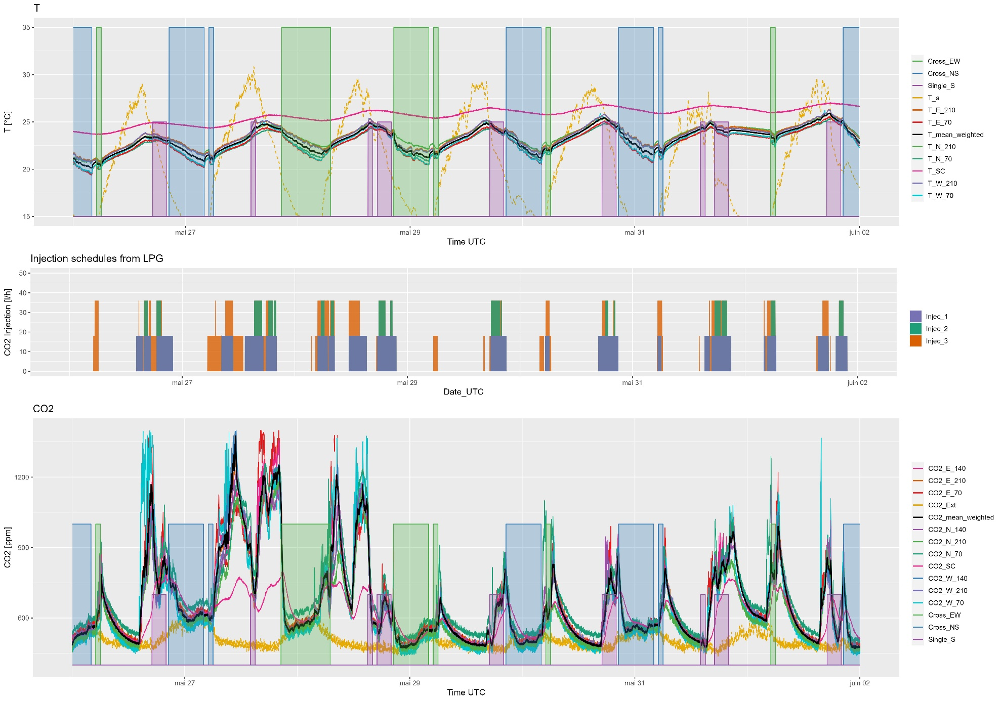
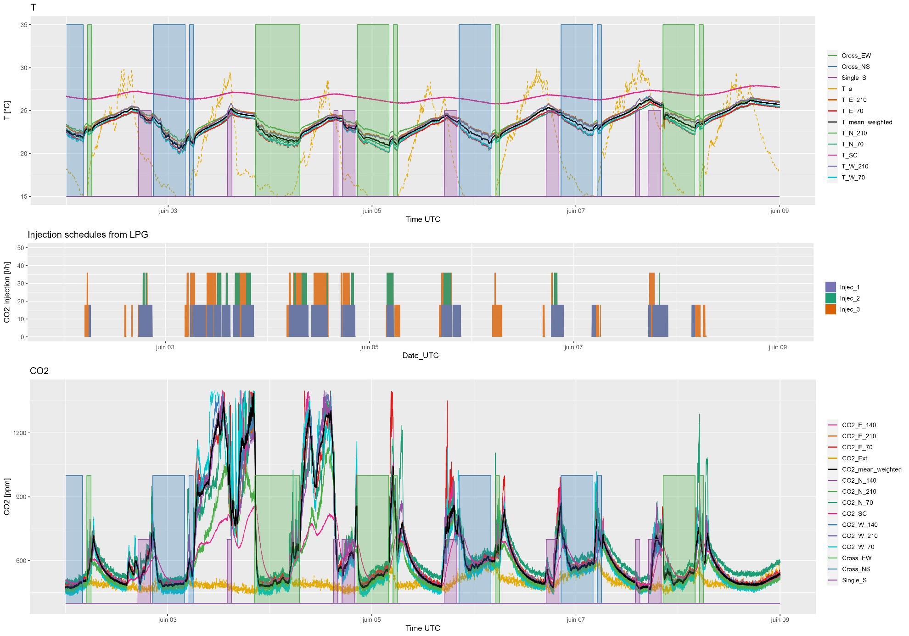
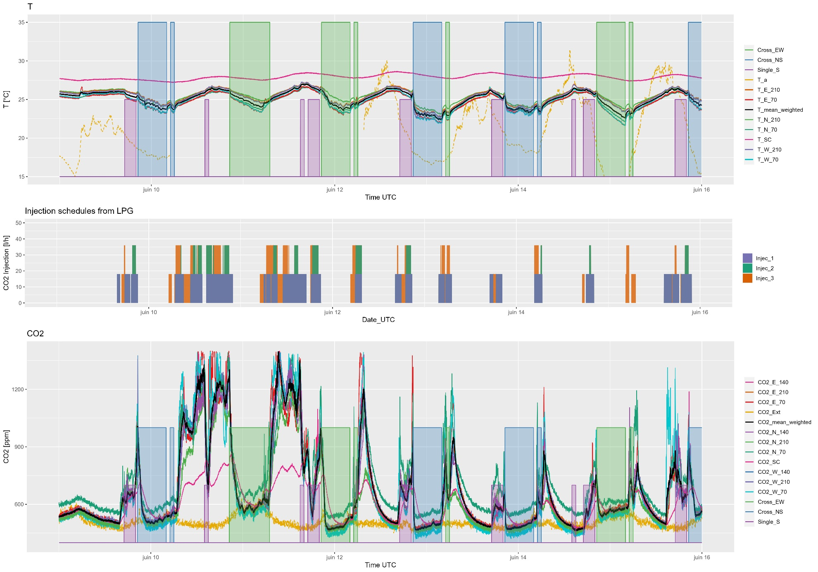
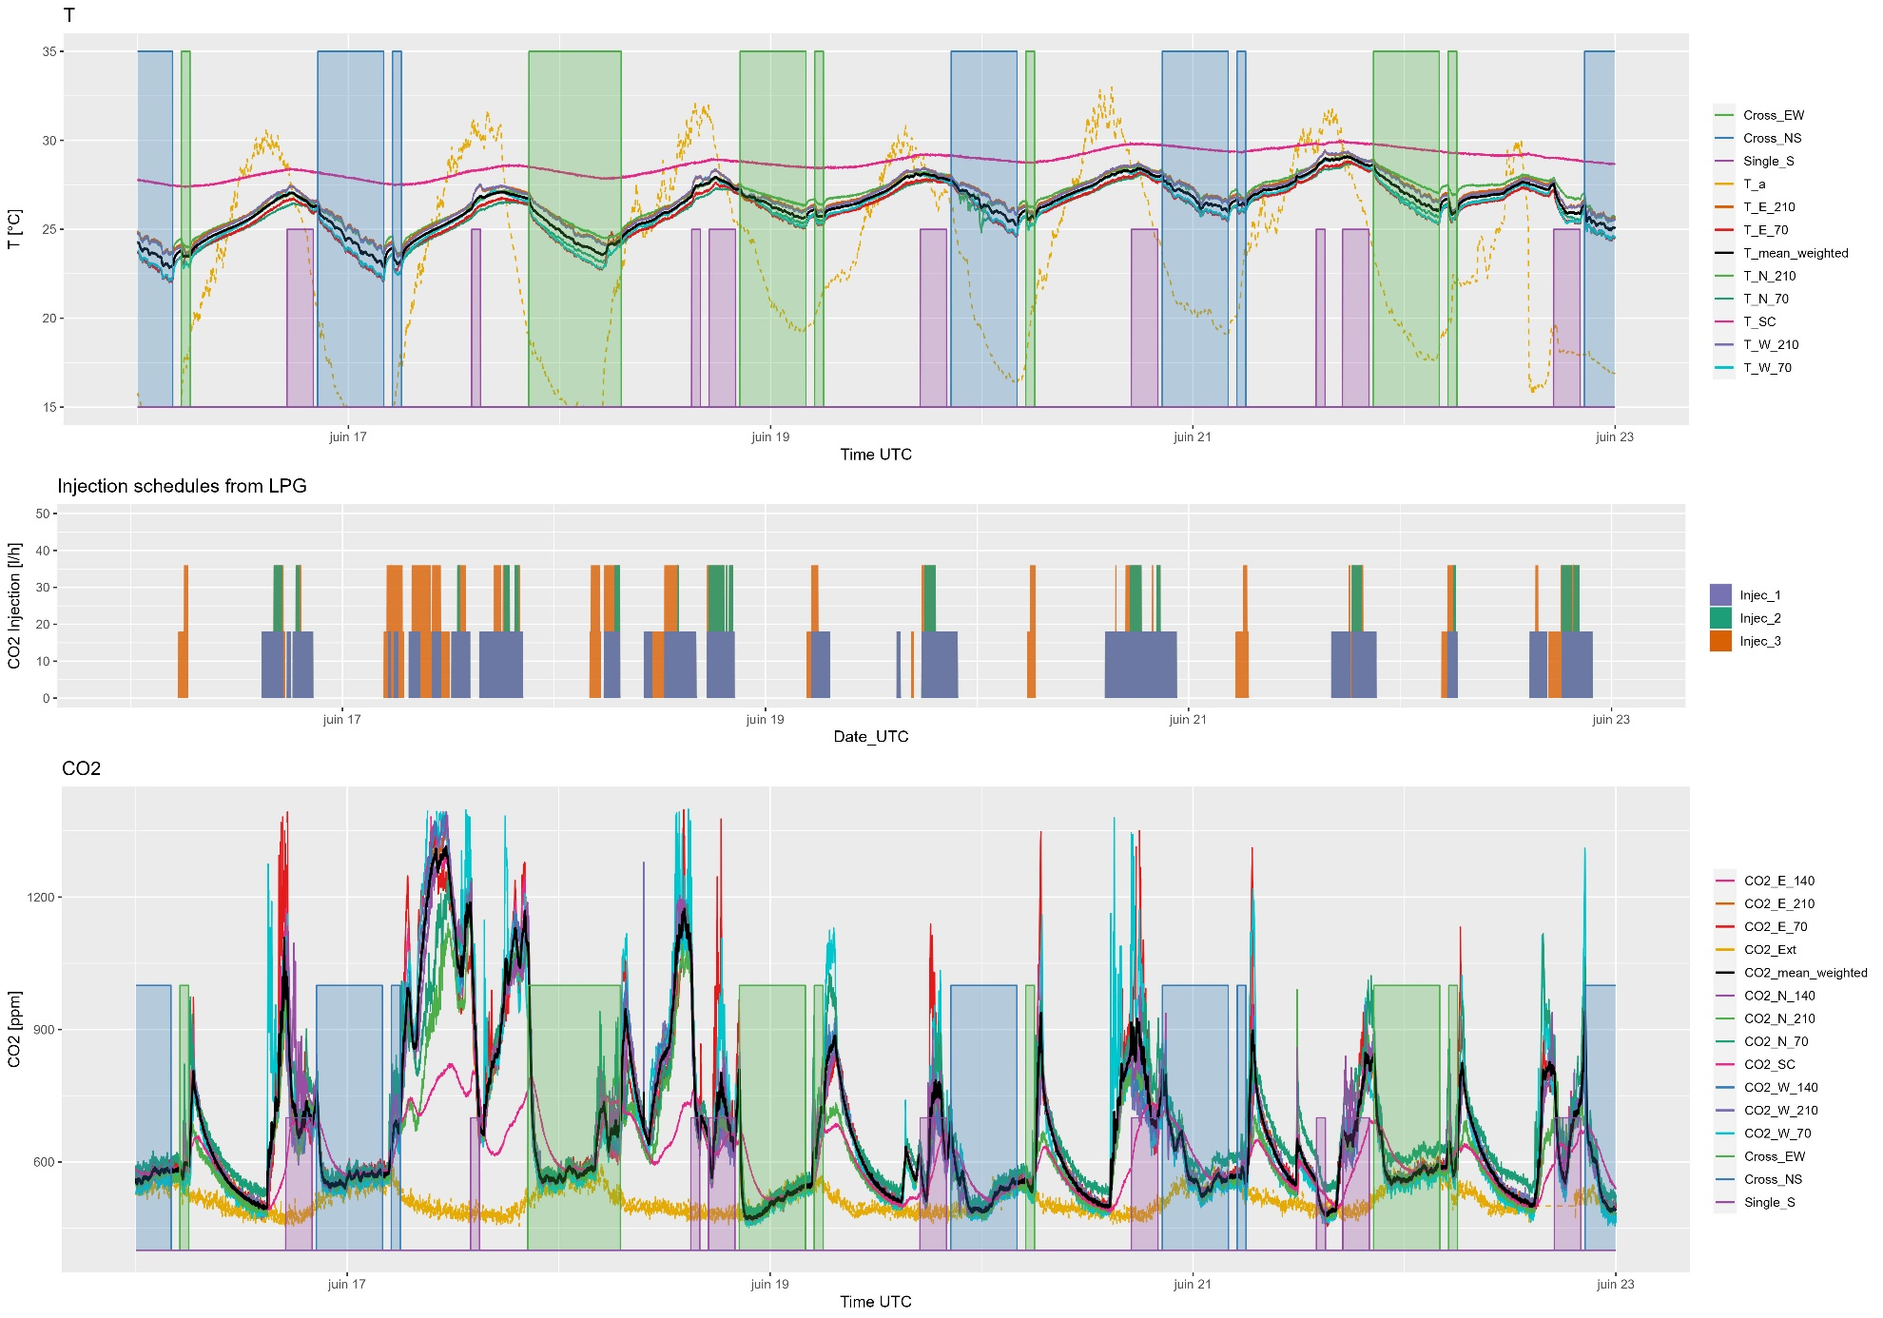
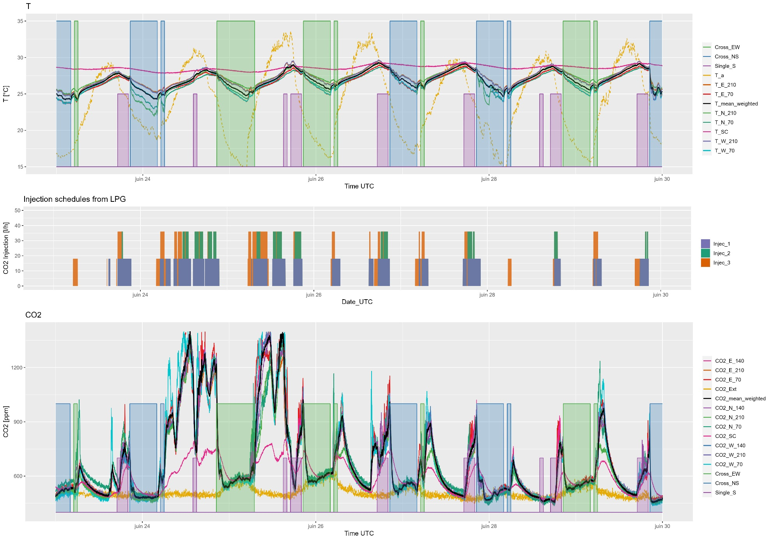
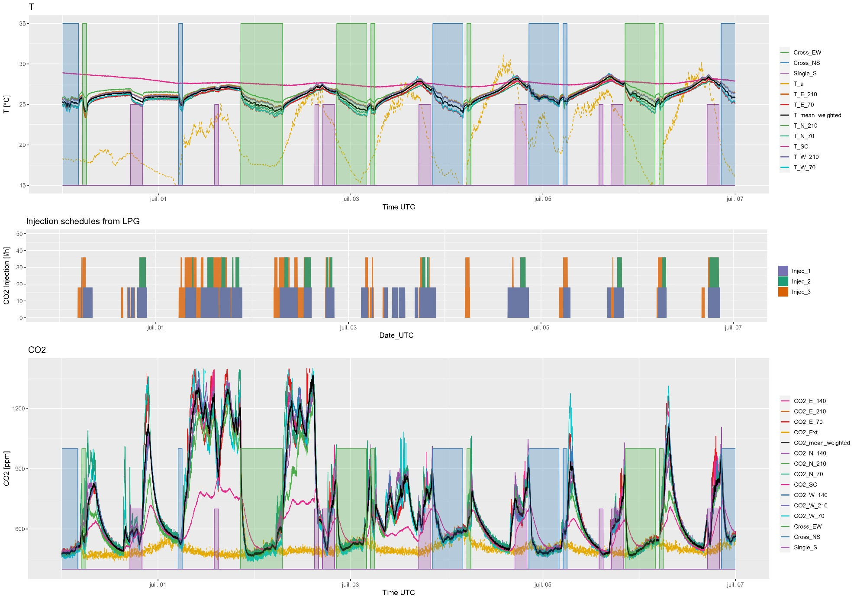
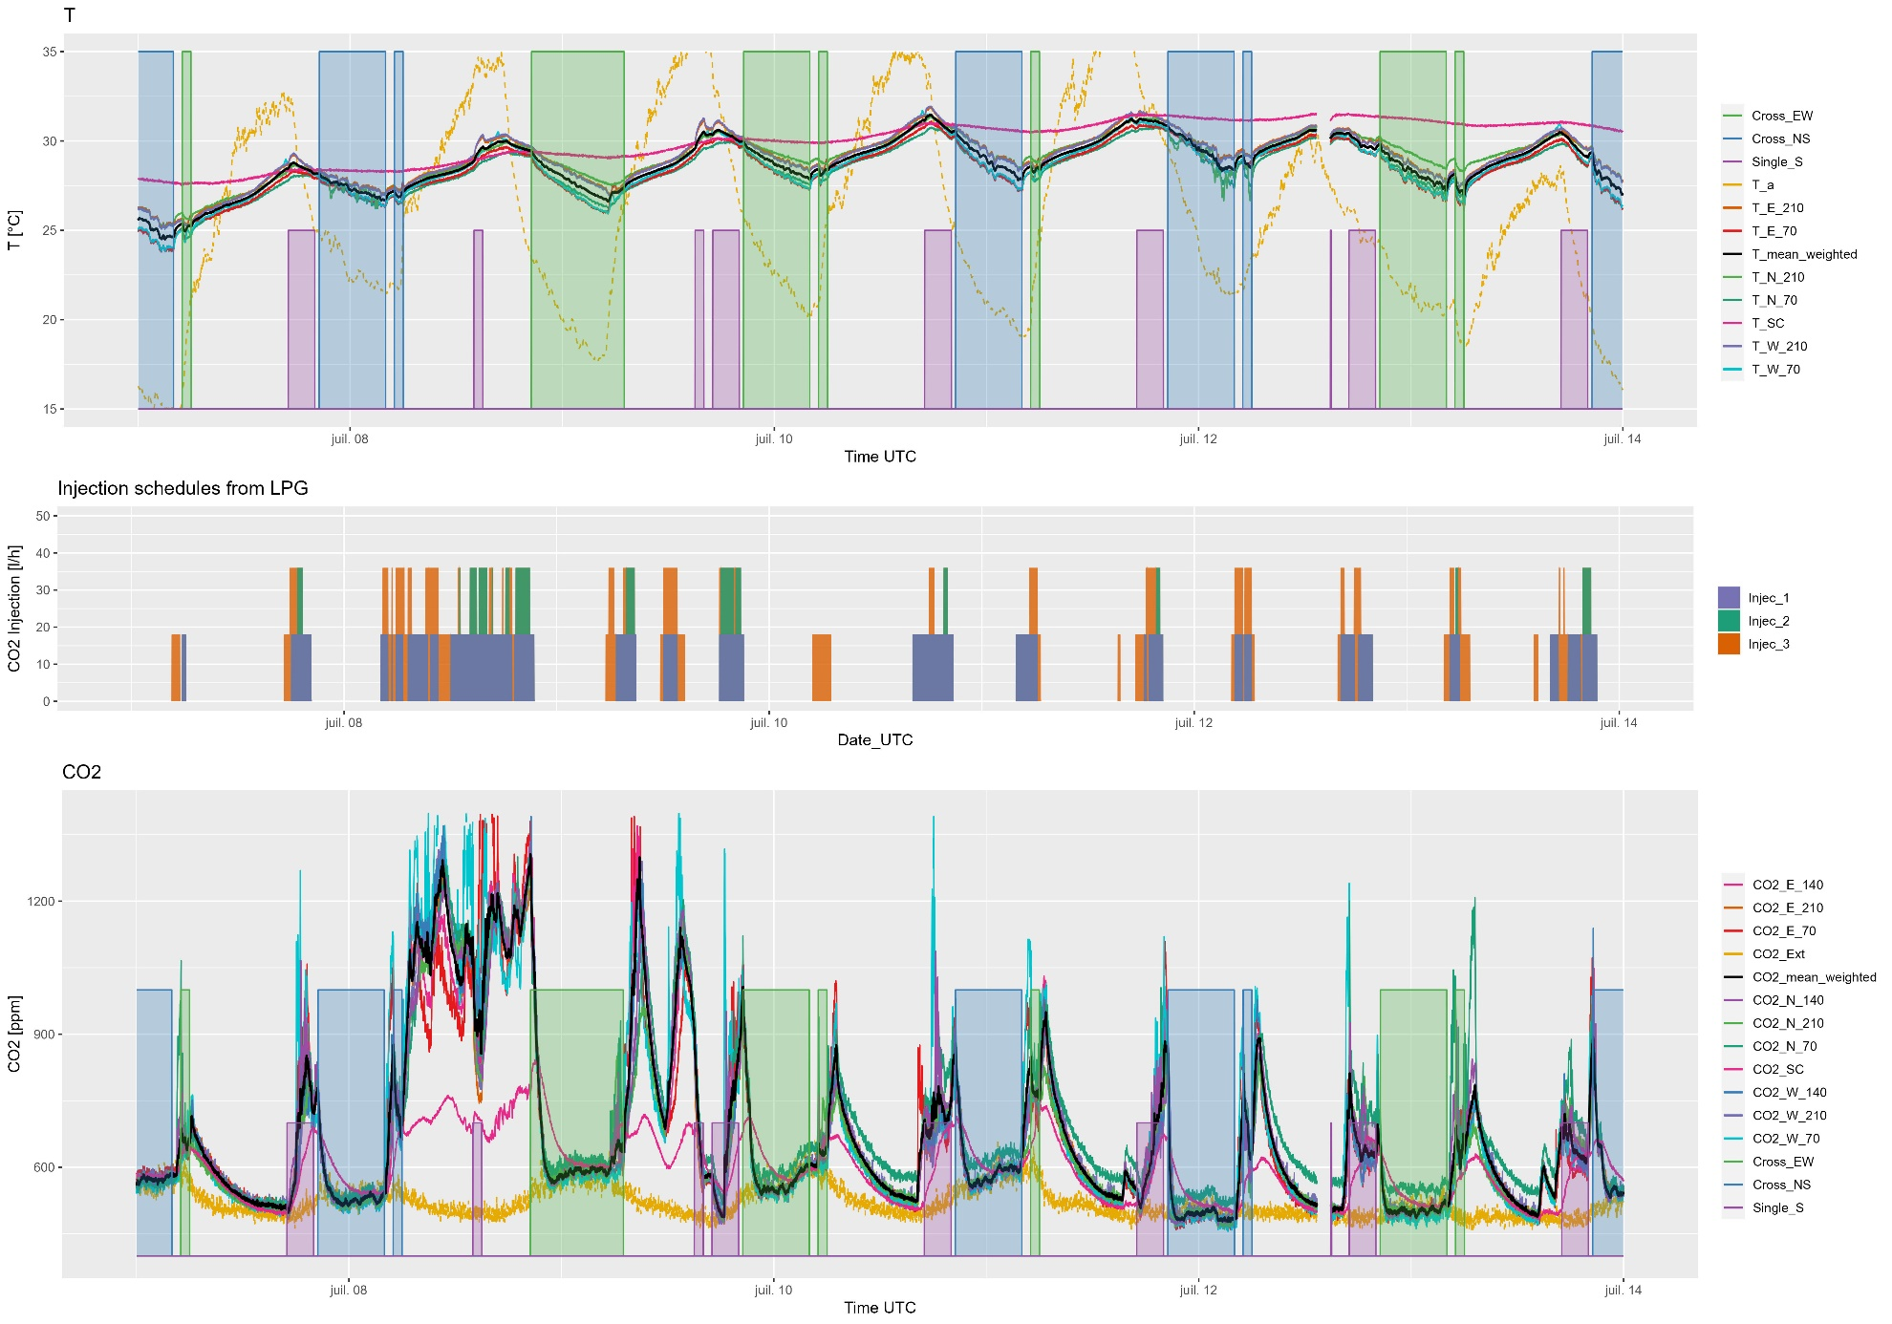
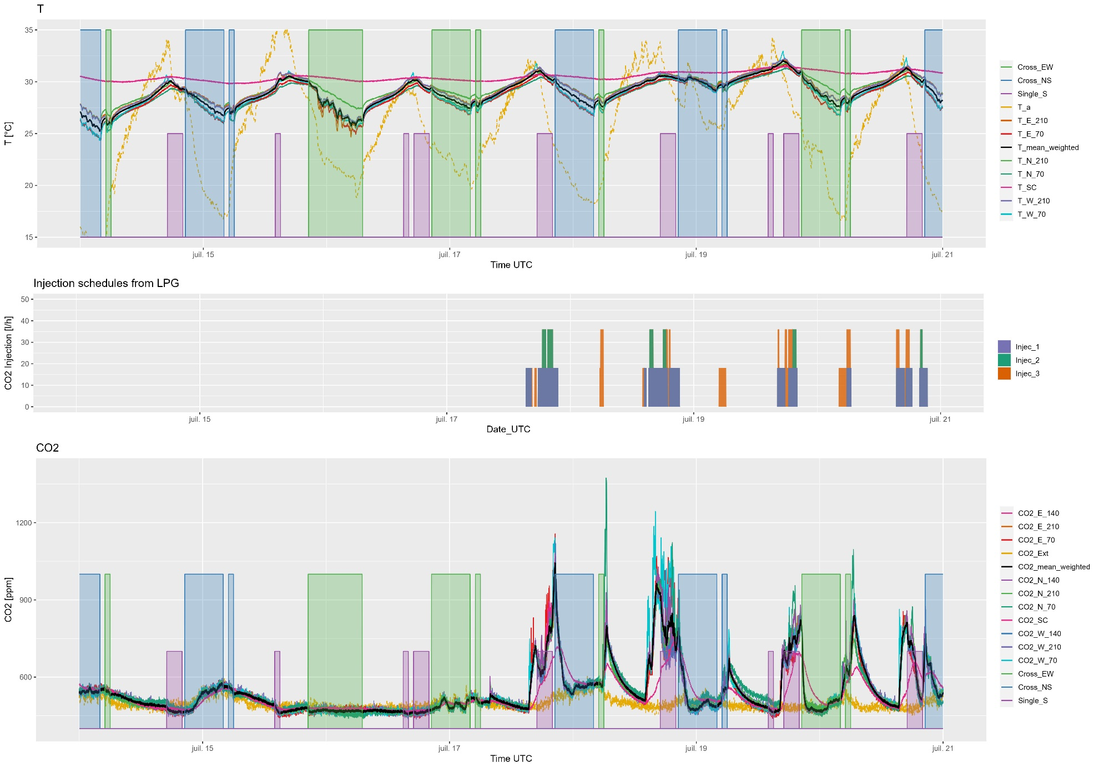
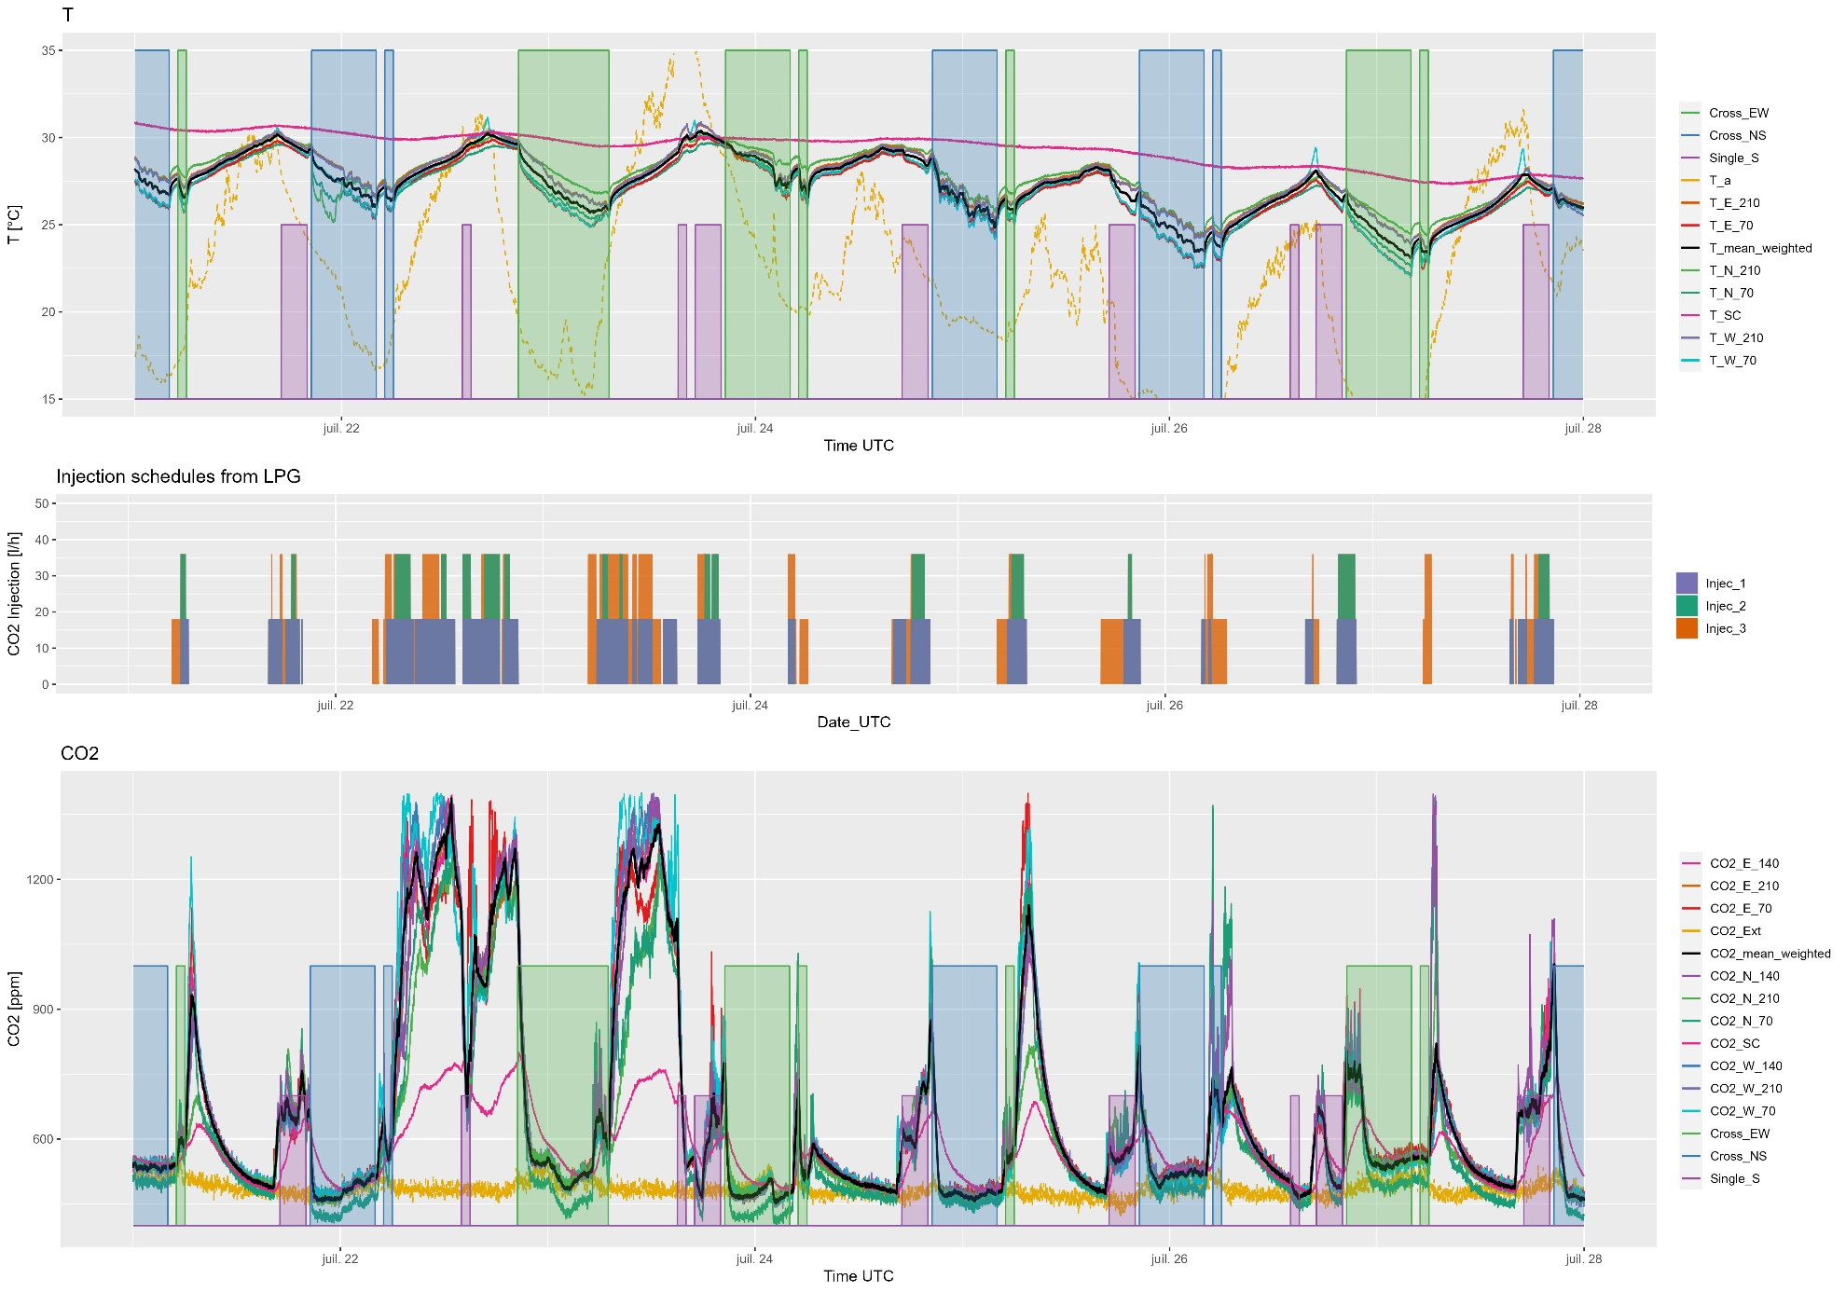
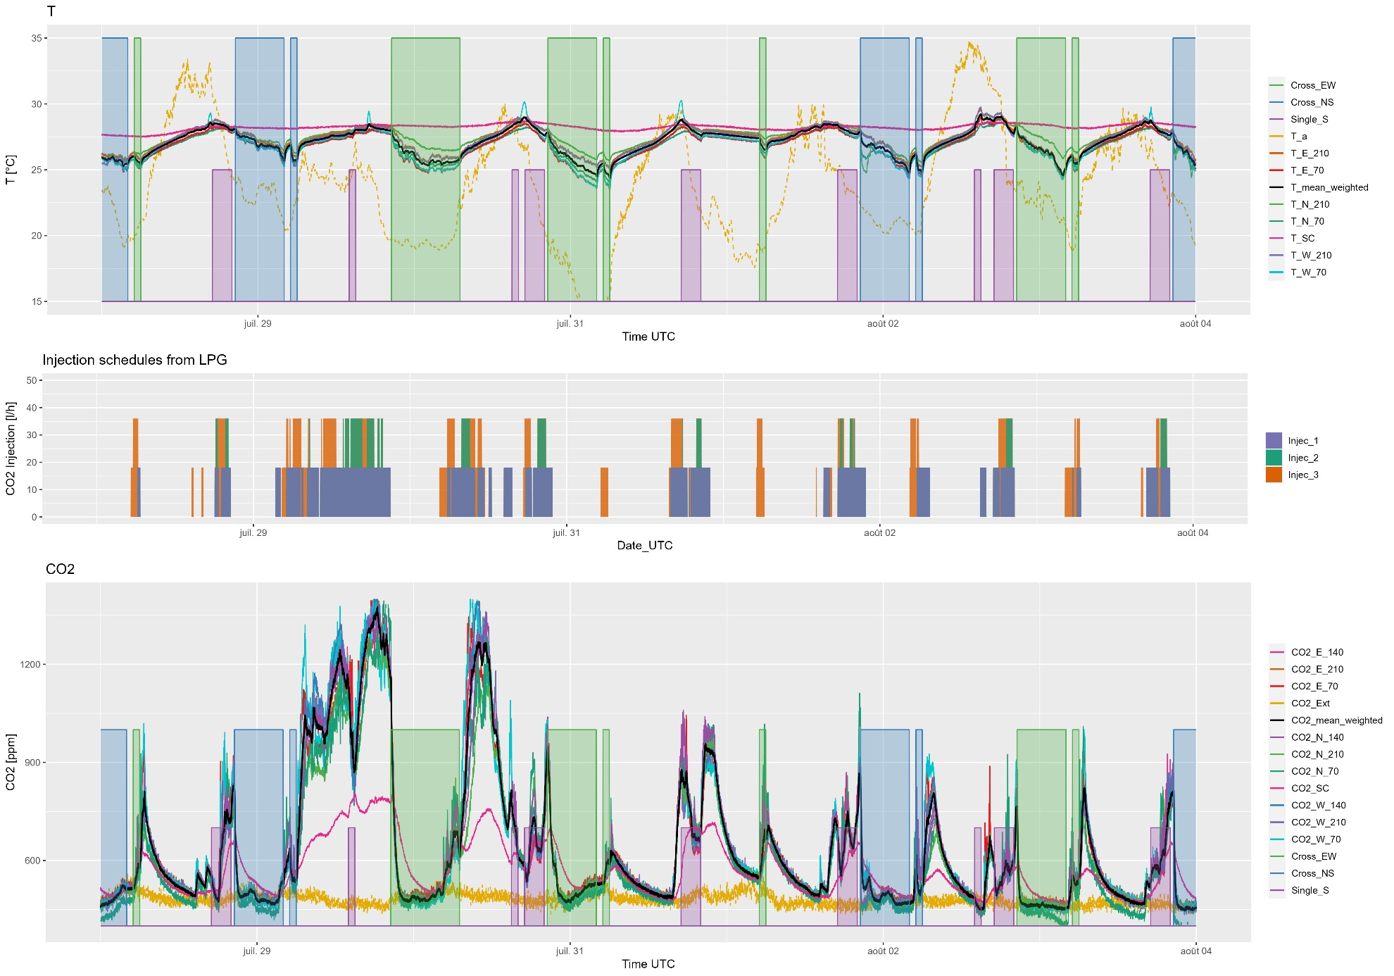
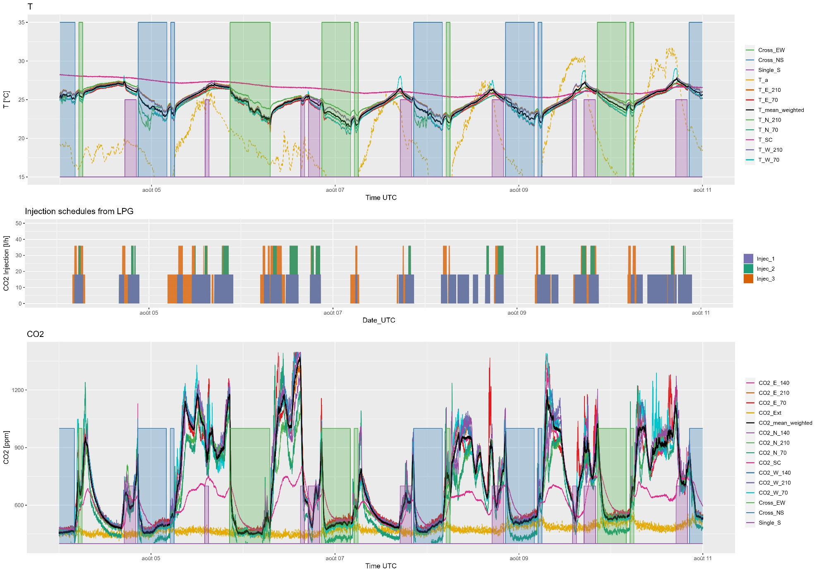
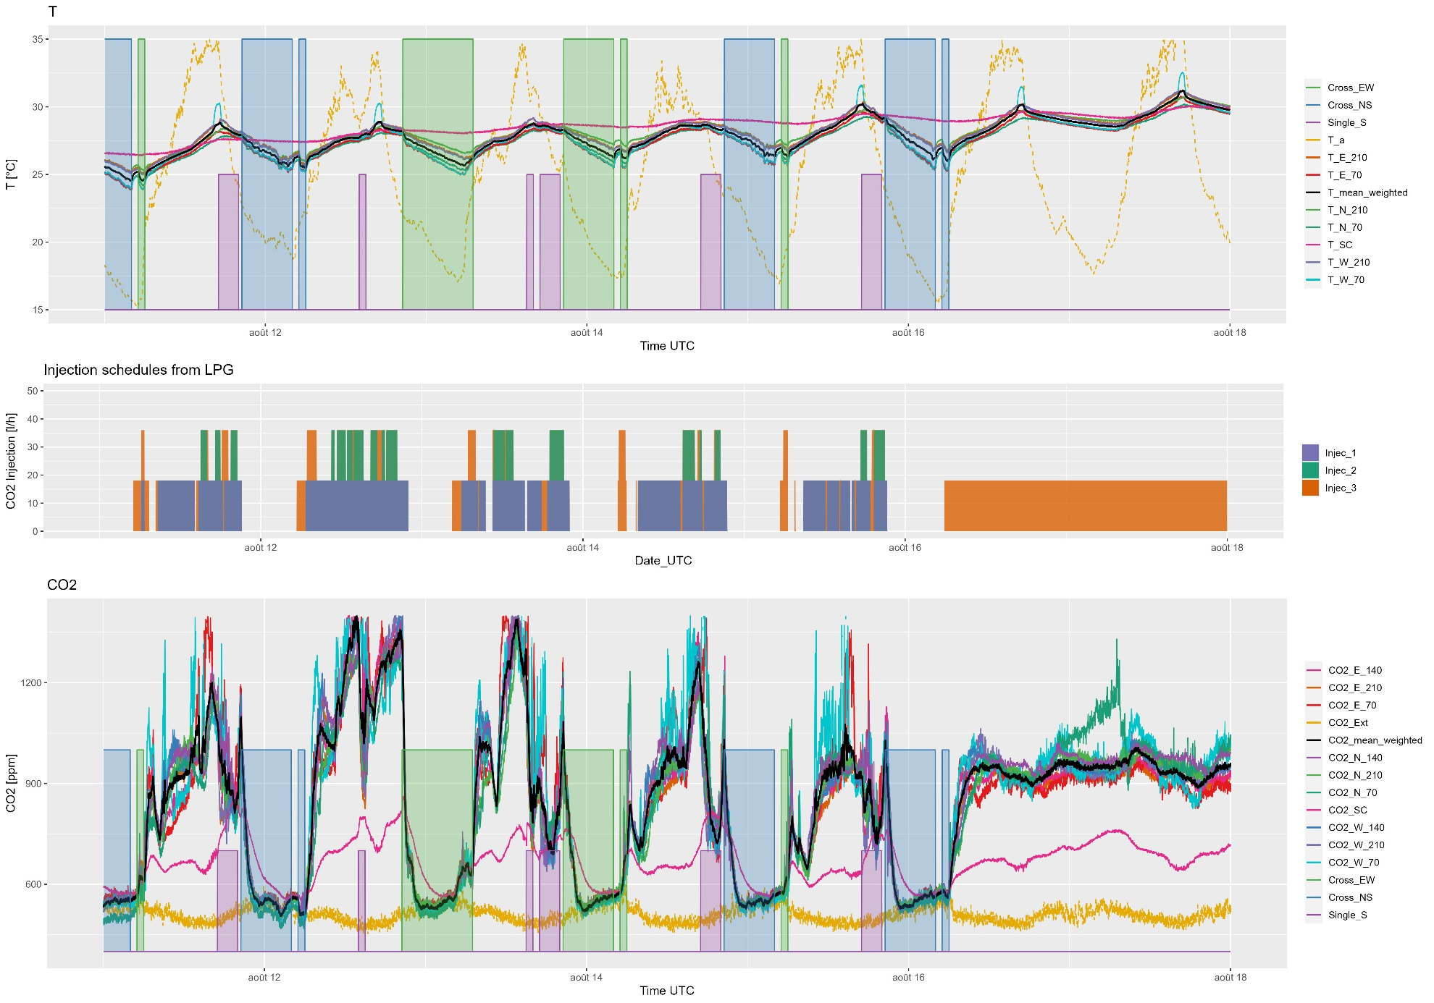
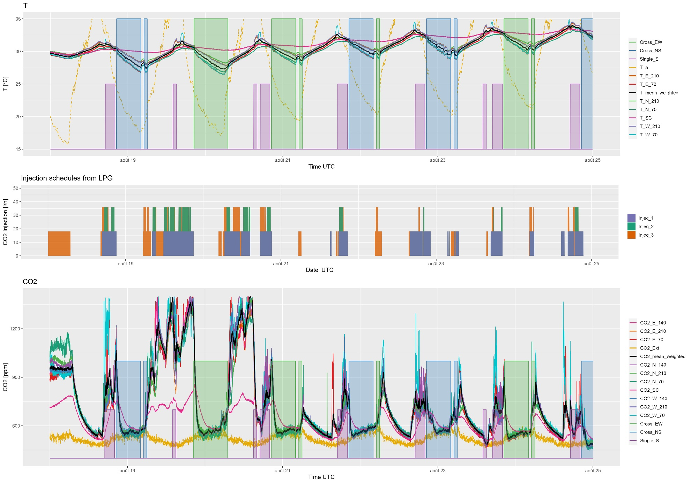
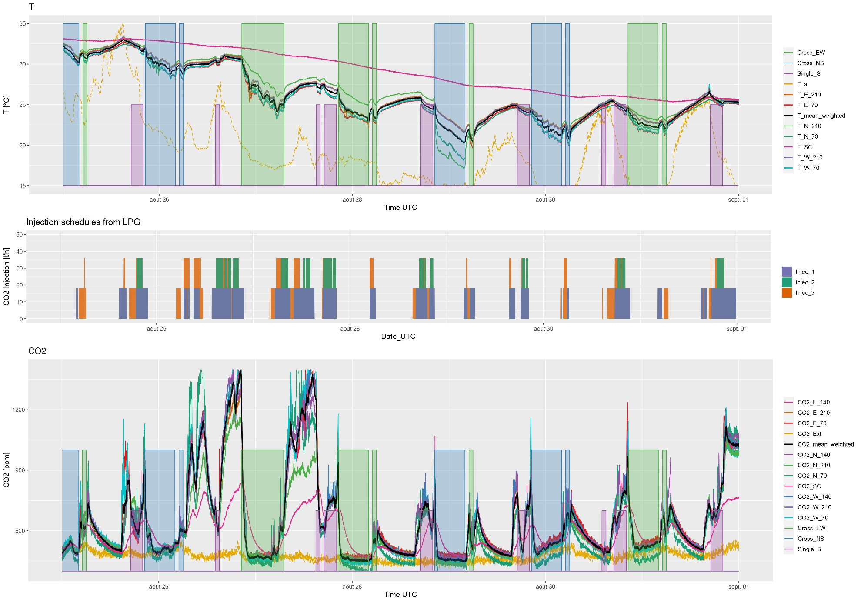
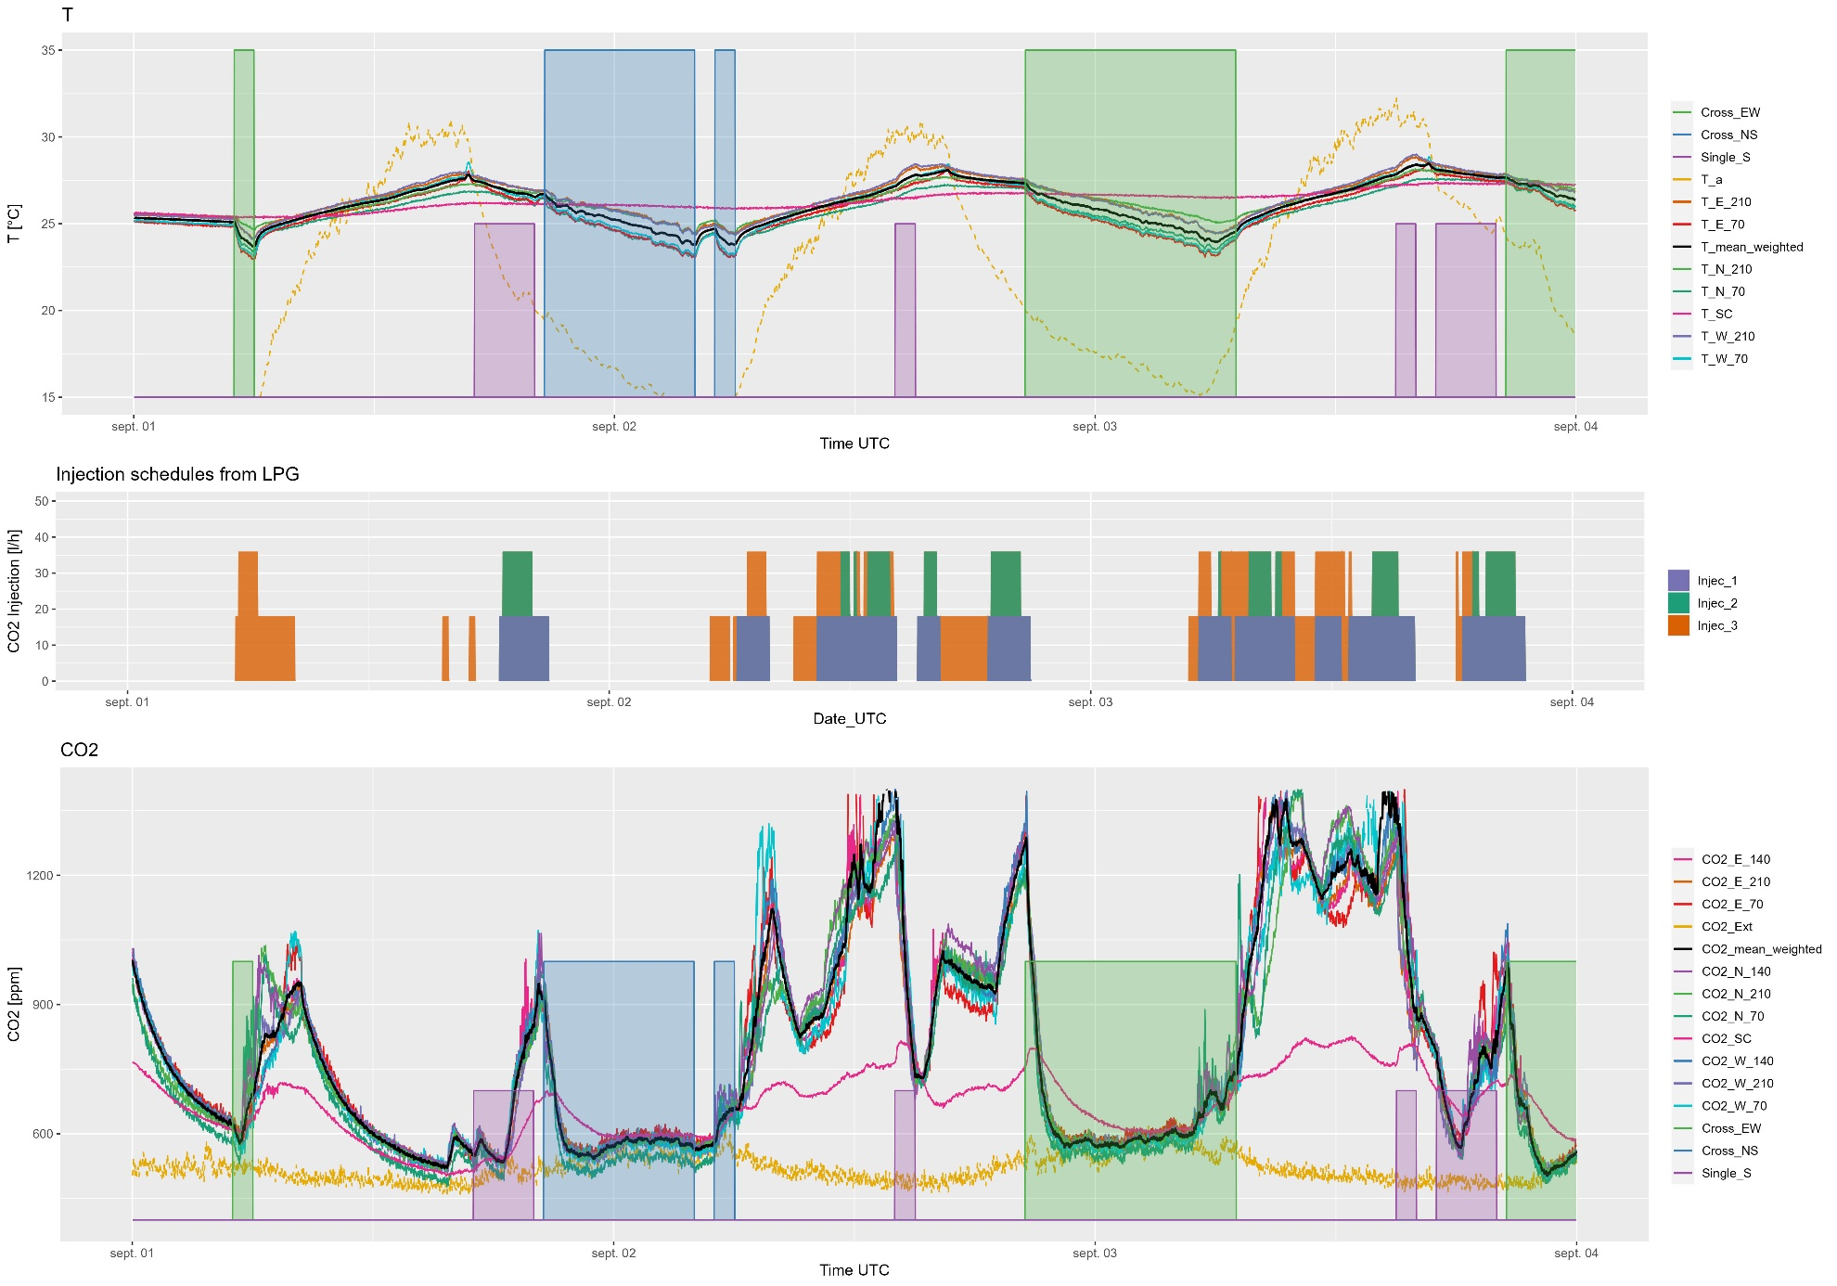
Figure 7: All temperature and CO2 measurements detailed by weeka

